**MEDIA STATEMENT FOR ALL NEWS EDITORS**

**Slug:** (Black Business Manufacturing Fund) **Monday, 26 July 2021**

_________________________________________________________________

**NEF announces Fund to support black manufacturers**

As South Africa responds to President Cyril Ramaphosa’s recent call to “accelerate the implementation of our Economic Reconstruction and Recovery Plan to rebuild our economy”, **the dtic** has allocated R150 million for the National Empowerment Fund (NEF) to establish the Black Business Manufacturing Fund (BBMF) to support black entrepreneurs in manufacturing various products locally across all key sectors of the economy.

***Supporting the manufacturing value chain***

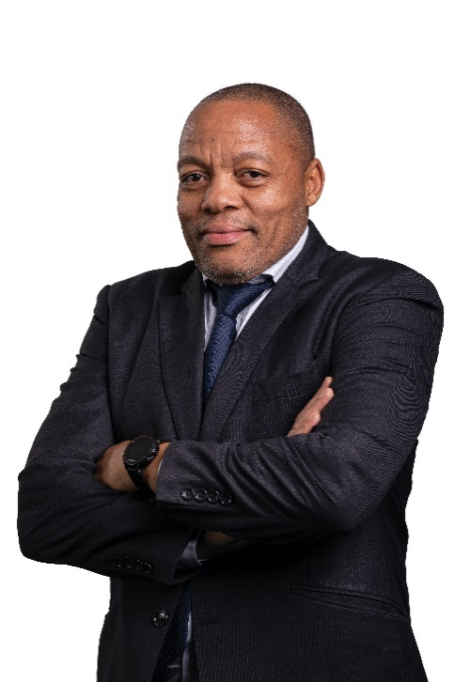Commenting on the Fund, Mr Nhlanhla Nyembe, the NEF’s Divisional Executive for SME & Rural Development, says: “This Fund is a strategic fit for the NEF and Government’s objective of increasing the country’s manufacturing capacity which is necessary to achieve inclusive economic growth. The Fund will support companies involved in the manufacturing value chain, focusing on value addition. These include processing of raw materials into inputs for finished goods, conversion of raw materials into finished goods and adding value into semi-finished and finished goods including processing products for consumption”.

The NEF is a Government-owned Development Financial Institution whose mandate is to promote and facilitate black economic participation through the provision of financial and non-financial support to black-owned and managed businesses.

He says over the years the NEF has supported black entrepreneurs to manufacture a range of products including cranes and aerial platforms, railway components, steel wheels and rims, car tracking devices, furniture, cotton fibre, textiles and clothing, sanitizers, medical masks and personal protective equipment, pesticides, condoms, mining components and roof tiles, among many others. “This is the track-record that we will build upon, along with the diverse range of internal investment and engineering expertise to help take this important task forward,” says Mr Nyembe.

***Funding criteria***

To qualify for BBMF funding, companies must be:

* Majority owned by black people – minimum of 51% black ownership;
* Registered and recognised under South African laws;
* Registered either as a private company (Pty Ltd), close corporation or co-operative;
* Registered for tax and in good standing with SARS, and have a valid tax clearance certificate;
* Involved in the manufacturing value chain (including making and processing of goods with some sort of value add to products;
* Create sustainable jobs;
* Commercially viable, demonstrating their ability to repay the loan;
* Looking for funding for the acquisition of plant, equipment and machinery; improvement and upgrading of manufacturing processes; raw materials working capital; costs associated with delivering under export contracts;
* Looking for funding for the importation of plant and equipment (provided that the business can demonstrate that such plant and equipment cannot be sourced locally); and
* Looking for funding for the importation of raw materials provided such raw materials cannot be sourced locally.

“The ultimate mission,” adds Mr Nyembe, “is to drive the manufacture of quality products at competitive prices for local and export markets while nurturing manufacturing businesses in the right direction with mentorship support where required”.

***A track-record of managing third party funds***

The NEF has attracted over R8.8 billion in third-party funds from public and private sector partners because as a DFI, we are a catalyst for unlocking economic value. Once transactions have been de-risked through various non-financial support interventions, including business incubation and entrepreneurial training where applicable, especially in the SME and rural transactions, as well as feasibility and related funding, third-party funders then have greater comfort and confidence to support what the market ordinarily views as high-risk transactions.

The NEF is a partner that is trusted by many to support black entrepreneurs across various sectors to pursue supply chain, entrepreneurial and other business opportunities.

Since its operational inception in 2004 up to the 30th of June 2021, the NEF had approved funding of over R11 billion for the benefit of **1 168 black-owned and managed businesses** countrywide, bringing dignity and stability to thousands of households through provision of **105 949** decent jobs.

**-Ends-**

|  |  |
| --- | --- |
| **For interviews** | |
| Moemise Motsepe  Marketing & Communications Manager  National Empowerment Fund  [motsepem@nefcorp.co.za](mailto:motsepem@nefcorp.co.za) | Mandla Mpangase  Deputy Manager, Marketing & Communications  [mpangasem@nefcorp.co.za](mailto:mpangasem@nefcorp.co.za) |